Step 0 Intake + Interview Filing Status, Dependency

Interview Notes: (See also: General Notes)
- George was a full-time student at a local college
- Mary paid $144 in Student Loan interest during the tax year
- The Browns paid $9,000 in rent while living in Dover through June (They had lived at the Dover address for many years)
- The Browns moved in July when they inherited a house in Denville. They paid $4,534 in property taxes, but had no mortgage payments. According to the postcard from the tax office: – Block=50001, Lot=00002, Qualifier is blank.
- Henry started receiving his pension from Fidelity this year
- Neither Henry or Mary are Veterans.
- The Browns filed for and are eligible for a Homestead Benefit property tax credit
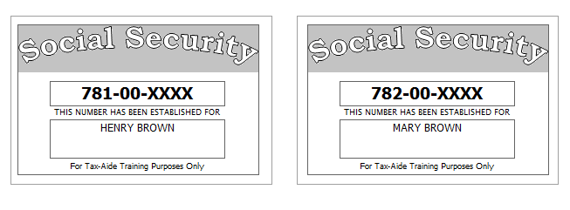
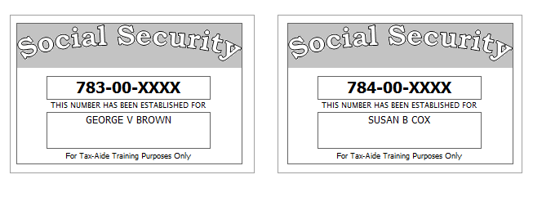

Step 1 Basic Information

TP Form / Note | TS Screen | Notes
SS Card | Start a New 2017 Tax Return  Available Taxpayer Profiles | Ignore the Profiles  Select “Enter Social Security Number” at the bottom of the screen  Enter the TP SSN twice and “Start Return”
Intake Sheet | What is your filing Status? | Answer: Filing Status: Married filing joint  Continue
SS Card  Intake Sheet  G-Note 2 | Personal Information  Taxpayer Information  Spouse Information  Address & Phone Number | TS: Enter all information using “Caps Lock”  Hint: Use Name and SSN from SS card. (Not Intake Sheet)  Hint: SSN format YYY-00-0752  TS: Birth date can be entered using drop down menu or filling in the field.  TS: Check any of the “Check here” questions that apply –  TS: Spouses last name auto populates when field is selected. Change if required.  TS- Check presidential election campaign fund for SP  TS: Enter Zip code- TaxSlayer fills in city and state. Correct if required  TS: Enter New Jersey as the Resident State  TS: Select Continue
Intake Sheet  G-Note 2, 3 | New Jersey Return | Hint: Begin NJ Checklist  TS: Select Municipality from drop down menu (Listed by county). Start typing Morris to quickly scroll down  TS: Answer question regarding dependent Health Insurance. Answer is Yes.  TS: Select Yes or No for the Gubernatorial Election Fund. See Intake Sheet page 3 and General Note 3. No for TP, Yes for SP.  TS: Five Digit Pin for TP and SP is automatically selected  TS: Select Continue
I-Note 1 | Dependents or Qualifying Person(s)  Do you have any Dependents or Qualifying Person(s) to claim on your return? | TS: Answer is “Yes”.
 | Dependent/Qualifying Child  Information | Add dependent information  Hint: Use name and SSN from SS card (Not Intake Sheet)  TS: Last name auto populates. Change if required  Answer: SSN format = YYY-00-0752  Check the “Check if” questions that apply  Answer: Both dependents are full time students, but only George is over 18 and a full time student at an eligible educational institution  Add second dependent information  Hint: Susan’s last name is Cox. Make the change.  TS: Select “Continue”

Federal AGI: 0 Federal Refund: 0 NJ Refund Amount: 0

Step 2 SSA-1099
TP Form / Note | TS Screen | Notes
SSA-1099 | Federal Section  Income  IRA/Pension Distribution Form 1099-R/RRB/SSA  - Begin  Social Security Benefits/RRB-1099 -Begin | Enter SSA-1099 Data  Hint: Use TP4F Scratch Pad to document Medicare Parts B, C, D. Insert total in “Taxpayer’s Medicare Premiums”. Amount = $1889  TS: Continue, Continue

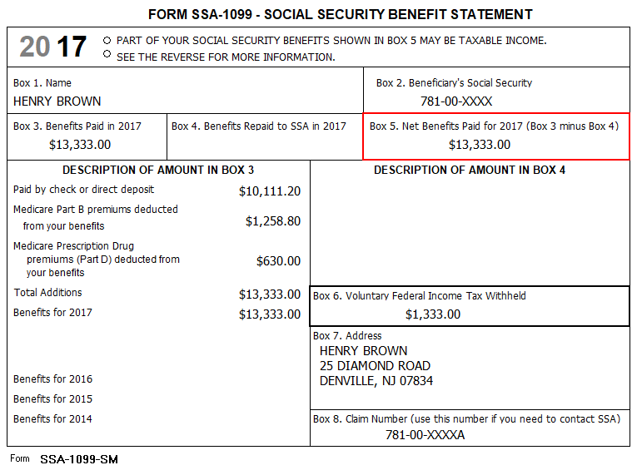

Federal AGI: 0 Federal Refund: 1,333 NJ Refund Amount: 0

Step 3 W-2 Green Grass Golf
W-2  Green Grass Golf | Left Menu - Income  Wages & Salaries Form W-2  Begin | Hint: Henry Brown W-2  Hint: Make corrections so that information matches the information on the W-2. TP address shown on the TS W-2 should match the paper W-2  Hint: Use EIN 70-9000752  Hint: If the name and address of the employer come up after inputting the employer Identification Number, check that the information is correct  Hint: Always round up for amounts ending in .50  Hint: Box 14 NJ Codes are selected from drop down menu. All other entries in box 14 are lumped under “Other”  Hint: If NJ State EIN auto populates, check to be sure it is correct  TS: Click Save & Enter Another

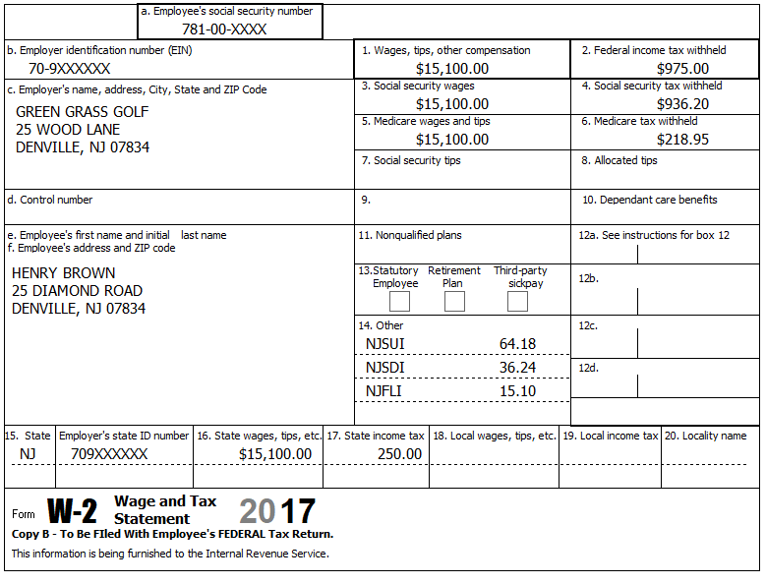

Federal AGI: 15,100 Federal Refund: 7,924 NJ Refund Amount: 2,216

Step 4 W-2 Joe’s Bar & Grill
TP Form / Note | TS Screen | Notes
W-2 Joe’s Bar & Grill | Add W-2 Statement | Hint: W-2 for Mary Brown  Hint: Make corrections so that information matches the information on the paper W-2  - Change address on TS W-2 to match paper W-2  Hint: Use EIN 70-8000752  Hint: If the name and address of the employer come up after inputting the employer Identification Number, check that the information is correct  TS: Certain characters are not allowed for E-File (#, ‘). TS will remove them once the form is saved  Hint: Check boxes 3-7 for correct entries  Hint: Always round up for amounts ending in --.50  Hint: Box 14 NJ Codes are selected from drop down menu. All other entries in box 14 are lumped under “Other”  Hint: If NJ State EIN auto populates, check to be sure it is correct  TS: Click continue NJ warning  TS: Click Continue

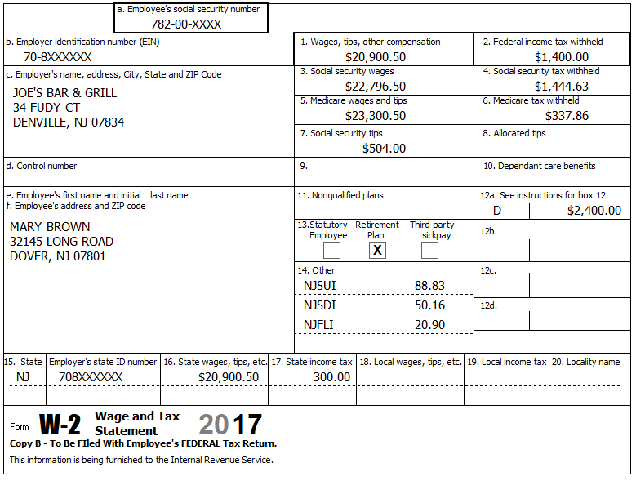

Federal AGI: 41,335 Federal Refund: 4,743 NJ Refund Amount: 800
Step 5 Interest 1099-INT
TP Form / Note | TS Screen | Notes
1099-INT  National City Bank | Left Menu - Income  Interest and Dividend Income, Form 1099-INT/ 1099-DIV  - Begin  Interest or Dividend Income -Begin  Interest Income, Form 1099-INT,Form  1099-OID…..  -Continue  Continue | Hint: Select for Taxpayer  Enter values that apply  Continue

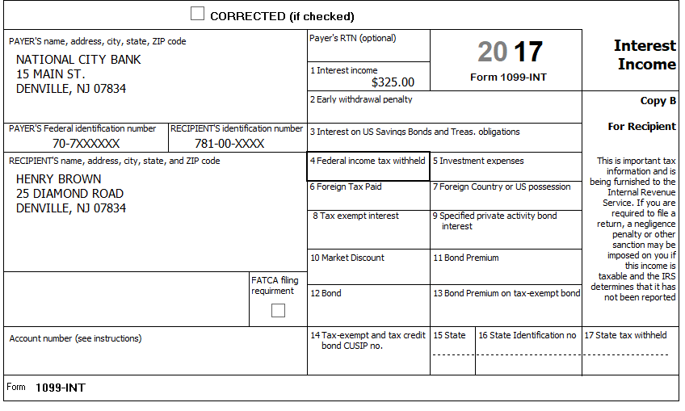

Federal AGI: 41,823 Federal Refund: 4,587 NJ Refund Amount: 755

Step 6 Dividends 1099-DIV
TP Form / Note | TS Screen | Notes
1099-DIV  Dreyfus | Add an Interest and Dividends  Dividend Income, Form 1099-DIV  Continue | Hint: Select for Taxpayer  Enter values that apply  Continue
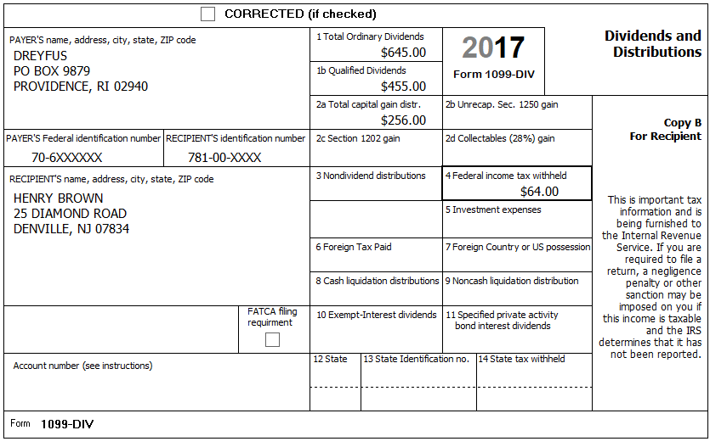

Federal AGI: 43,174 Federal Refund: 4,302 NJ Refund Amount: 641

Step 7 1099-R

TP Form / Note | TS Screen | Notes
1099-R  Fidelity Investments | Left Menu -Federal Section- Income  IRA/Pension Distribution Form 1099-R / RBA, SSA – Edit  Add or edit a 1099-R  -Begin | Hint: “This 1099-R is for Henry  Hint: EIN – 70-5000752  Hint: Make corrections so that information matches the information on the 1099-R  Hint: Taxable amount defaults to Gross Distribution Amount. Adjust as required.  TS: You do not have to select a State for income to go to the State return.  TS: Continue

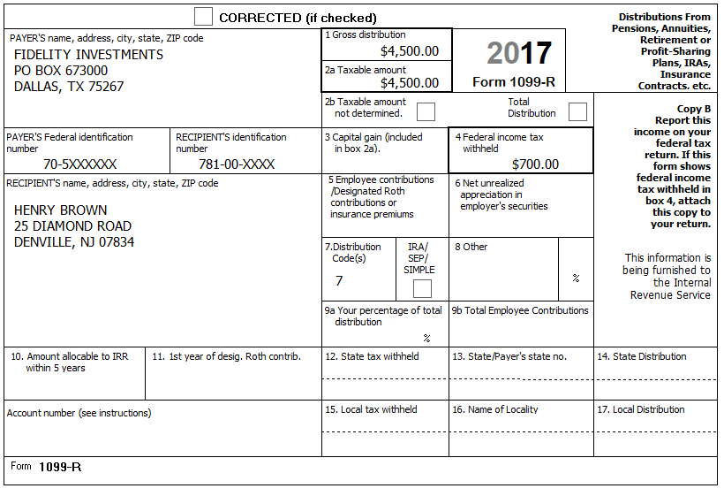
Federal AGI: 51,462 Federal Refund: 2,311 NJ Refund Amount: 94

Step 8 Unemployment 1099-G

TP Form / Note | TS Screen | Notes
1099-G  NJ Dep of Labor | Left Menu- Federal Section - Income  UnemploymentCompensation Form 1099-G Box 1  – Begin  Add or Edit a 1099-G  - Begin | TS: This 1099G worksheet is for the: Spouse  Hint: Phone number not required  Hint: State information not required  Continue
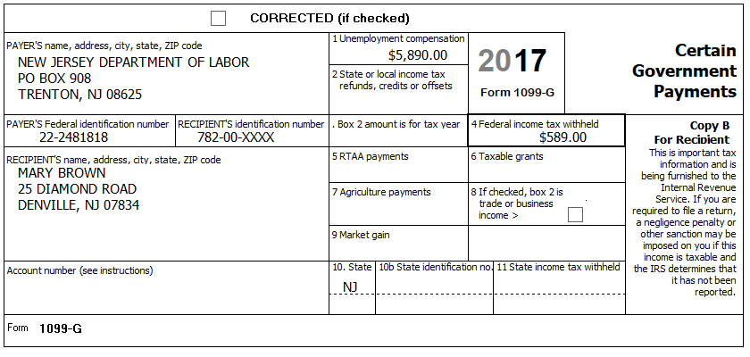
Federal AGI: 58,950 Federal Refund: 1,782 NJ Refund Amount: 94
Step 9 Student Loan Interest
TP Form / Note | TS Screen | Notes
I-Note 2 | Left Menu  Federal Section – Deductions  Enter Myself  Adjustments - Begin  Student Loan Interest Deduction - Begin | Enter Student Loan Interest Amount  Continue to Deductions

Mary paid $144 in Student Loan interest during the tax year

Federal AGI: 58,806 Federal Refund: 1,805 NJ Refund Amount: 94
Step 10 Itemized Deductions – Taxes You Paid
TP Form / Note | TS Screen | Notes
I-Note 4 | Left Menu-Federal Section -Deductions – Enter Myself  Itemized Deductions – Begin  Taxes You Paid - Begin | Enter real estate taxes paid  Go to ADD SALES TAX WORKSHEET and enter ZIP Code and 365 days living in NJ  Continue back to Deductions
 | Continue back to Deductions  -Compare Deductions – Begin | Check to see if using itemized deductions or standard deductions  - Standard Deduction= 13,950 Itemized Deductions – 5,383  Continue

The Browns moved in July when they inherited a house in Denville. They paid $4,534 in property taxes but had no mortgage payments.

Federal AGI: 58,806 Federal Refund: 1,805 NJ Refund Amount: 94
Step 11 Compare Standard vs Itemized Deductions

TP Form / Note | TS Screen | Notes
 | Federal Section  Deductions  Enter Myself  Compare Deductions - Begin | Check to see if using itemized or standard deductions.  Itemized = 5,383  Std = 13,950  Hint: You can view Schedule A (Itemized Deductions) by clicking on the Print Icon next to Itemized Deductions in the Deductions Menu.  Continue

Federal AGI: 58,806 Federal Refund: 1,805 NJ Refund Amount: 94
Step 12 Health Insurance

TP Form / Note | TS Screen | Notes
G-Note 2 | Left Menu-Health Insurance  Start Questionnaire | Answer questions in the Health Insurance Section

Every person on the return had health insurance that met Minimum Essential Coverage rules for the entire year. They did not purchase it through the marketplace.

Federal AGI: 58,806 Federal Refund: 1,805 NJ Refund Amount: 94

Step 13 New Jersey Return

TP Form / Note | TS Screen | Notes
I-Note 3,4,6,7  G-Note 2,3,4 | State Return –Edit  Basic Information - Edit  Credits  - Property Tax/Deduction-Begin | Hint: Use the NJ Checklist to enter NJ items  HINT: Check Basic Information  Save  Hint: Use scratch pad at TP4F to determine the proper value for Property Tax Paid  Hint: Property Taxes Paid = (rent*.18) + Property taxes paid  - (9,000*.18) + 4,534 = $6,154  Hint: Taxpayer meets Property Tax Eligibility Requirements  Hint: Taxpayer was a homeowner in 2017  Hint: Brown filed for homestead benefit  Hint: Enter the Block and Lot numbers  Hint: County Property Located in Denville.  Save back to the beginning of the State Return

The Browns paid $9,000 in rent while living in Dover through June (They had lived at the Dover address for many years)
The Browns moved in July when they inherited a house in Denville. They paid $4,534 in property taxes but had no mortgage payments. According to the postcard from the tax office: – Block=50001, Lot=0002, Qualifier is blank.
The Browns filed for and are eligible for a Homestead Benefit property tax credit
County Property located in: Morris-Denville
They had no out-of-state purchases on which they did not pay Use tax

Federal AGI: 58,806 Federal Refund: 1,805 NJ Refund Amount: 201

Step 14 Prepare for e-file

Intake Sheet  G Note 5 | Left Menu – e-file – | TS – Clear up any diagnostic messages (if any)  TS: Select Federal Return Type “E:file: Direct Deposit”  Next  TS: No entries in Fees section except for Client email address  TS – Pin numbers for e-file are automatically selected  Next  TS: Select State Refund Type “E:file: Direct Deposit”  Next  TS: Enter Bank Information – Name of Bank not required. Deposit amount is required. Click “PULL REFUND”  Next  TS: Skip Third Party Designee Info  Next  TS: Consent to Disclose Tax Return Information – Check DENY and enter 5 digit pin ( any 5 digit number) and date for TP and SP  Next  TS – Questions – Answer questions from Intake sheet Part VII, lines 5.6 and 7  Next  TS: Skip TP ID Information Screen  Save  You are Done

They want to handle any state refund / amount due like their federal refund / amount due

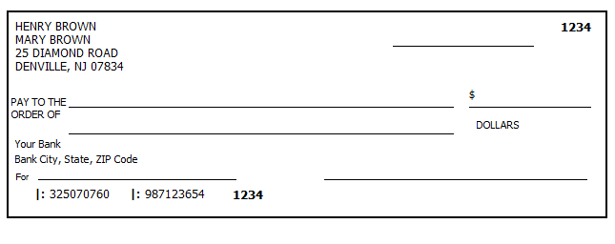

Federal AGI: 58,806 Federal Refund: 1,805 NJ Refund Amount: 201

